## 1.1. LOCATION OF VTIB

The Vocational Training Institute Besttechnology (VTIB) has it’s head office located in the Littoral region of Cameroon, precisely in Douala 5 of the Wouri division. We are at Ange Raphael terminus cite. The block diagram in figure 1.1 below is a summary of our location.

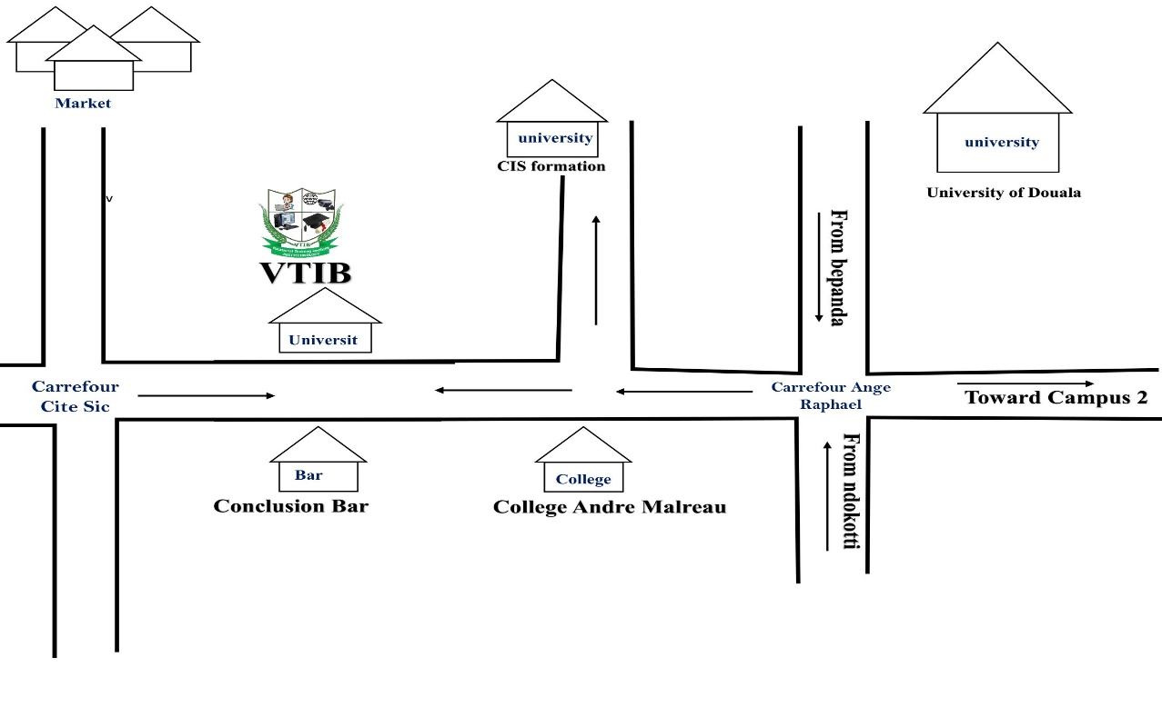

Figure 1.1: Drafted Location of VTIB

## 1.2. ABOUT VTIB

The Vocational Training Institute Besttechnology is an institution accredited by the Ministry of Vocational Training and Employment MINEFOP on the 24 of February 2022. Specialised in computer science and Information Technology, we train, certify and place candidates for their dream career jobs. Our job has seen adults build skills, confidence, gained self-esteem and employment over the passed years.

## 1.3. HISTORICAL BACKGROUND

Founded on the 10 June 2020 by Engr. BESONG MICHAEL EGBE who is the Chief of Center, the vision came just in time when the entire country and the educational system was shut down due to the deadly Covid-19 pandemic Disease. VTIB launched a free E-learning application known as teachers-spot (<https://teachers-spot.com>), that provided rich free video tutorials and academic materials to both secondary and high school students, as a means to help the government fight against the deadly disease. Since then, VTIB is becoming the leading force in professional trainings and certifications, IT installations, Solution provider and consultancy. VTIB is known for its young skillful labor force of competent amazing Engineers whose main goal is transforming the society with IT.

## 1.4. VISION, VALUES, AND MISSION

**VISION**

Powered by innovation, guided by integrity, delivers quality solution to build the digital delta.

**VALUES**

* We strive to exceed customer expectations.
* VTIB is result oriented so we seek continuous improvement through aggressive and attainable goals.
* Committed to innovations, we transform a beginner to a professional and solicited expert in the domain of Information Technology.
* We are honest and fair in our dealings with customer, partners, shareholders and each other.

**MISSION**

* The mission of VTIB is reduced in the statement: “**WE BRIDGE** **THE GAB TO COMPANIES**”, VTIB is formed to train, certify and improve the technical knowledge of young Cameroonians in various IT domains.

## 1.5. SERVICES

VTIB is a multi-service company with prime focus on information Technology services, Professional Training and Certifications. Services offered include:

* + 1. **INFORMATION TECHNOLOGY SERVICES**

VTIB provides many IT services to other companies and third parties. Examples of services provided are: Network Planning, Installation and Configuration; Computer Laboratory setup with thin clients; Camera installation and supervision with remote monitoring; Equipment procurement and maintenance; Web Application Development and Desktop Application Development (Bespoke solution).

* + - 1. **Computer Network Planning, Installation and Configuration**

Our Network Design, Equipment Purchase, Installation and Configuration is of high standards and meets up with international norms and standards. From our design to Choose of equipment, to deployment is what accounts for the high performance, speed and reliability that we are known for. Take a look at figure 1 below:

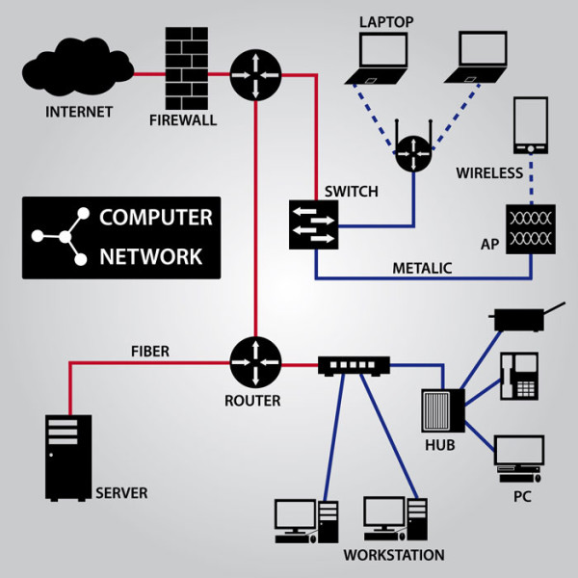

Figure 1.3: Computer Network Deployment

* + - 1. **Computer Laboratory setup with thin clients**

Computer Laboratory setup in companies, schools and in offices is another service offered by B. T & C. Reliable and cost-effective laboratories with thin clients.

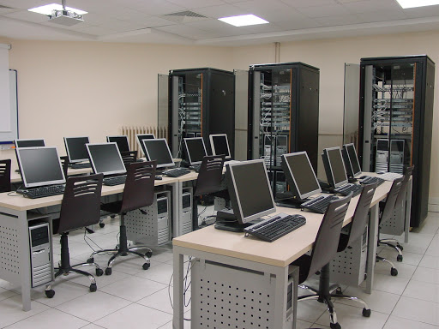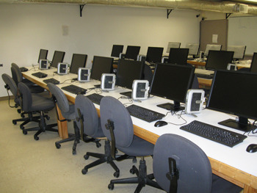

Figure 1.4: Thin Client Laboratory

* + - 1. **Camera installation and supervision with remote monitoring**

Security Camera Installation with Remote Monitoring. Monitor your Business, Home or School from anywhere at any time. BESTTECHNOLOGY & CO gives you best services at best prices.

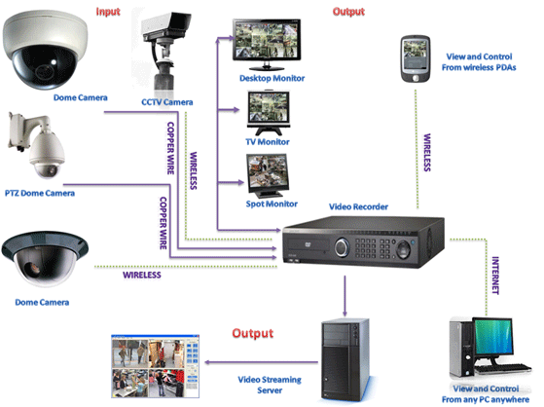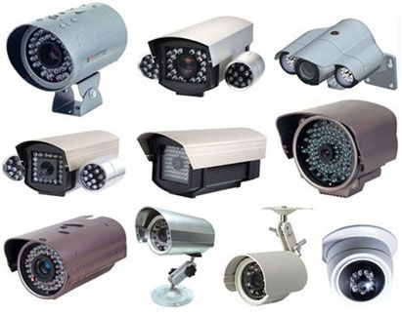

Figure 1.5: Camera Surveillance Installation

* + - 1. **Equipment procurement and maintenance**

Equipment procurement and supply. B. T & C provides you with equipment’s of mark, maintains your network and failed equipment’s.



Figure 1.6: Equipment Procurement & Supply

* + - 1. **Web Application Development.**

Secure web application development, E- MARKETand E-banking websites, Pen testing and security audit of web applications.

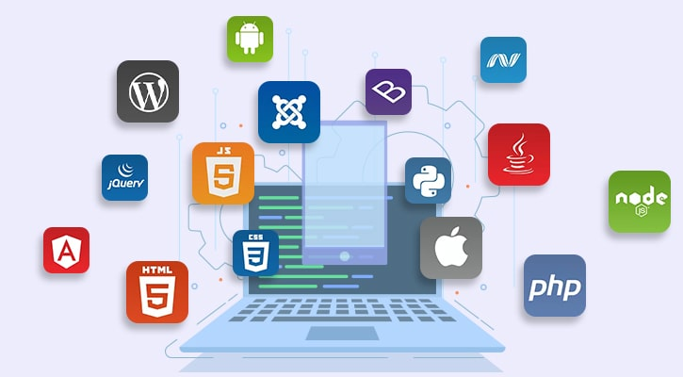

Figure 1.7: Cross Platform Web Application Development.

* + - 1. **Desktop Application Development.**

Desktop application development with modern technologies and programming languages. Robust and Accurate computing with our software solutions.

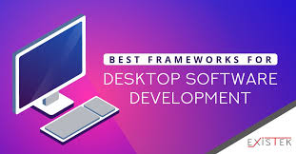

Figure 1.8: Best Desktop Application Technologies.

* + 1. **PROFESSIONAL TRAINING ON TEACHING ONLINE AND EDUCATIONAL TECHNOLOGIES**

We train teachers and lecturers on how to prepare and deliver online lectures using different ICT applications, tools and technologies. The three days workshop on online lectures usually focus on primary, secondary and university teachers/lecturers. It prepares them on overcoming the present challenge of teaching online while maintaining classroom experience. Below are some online training applications included in our workshops:



Figure 1.9: Online teaching applications / Educational Technologies

* + 1. **PROFESSIONAL CERTIFICATION PROGRAMS**

The two to three months professional training and certification programs offered by the BESTTECHNOLOGY and CO, is to fill the gabs and lapses created by our universities in the training of our students. Graduates from our universities and institutions are no longer absorbed by companies, due to their incompetency and lack of professional skills. Joblessness, very low salary and exploitation of young labor is what results from poor training by the universities. B. T & C therefore brings value back to fresh graduates, by impacting them with the professional skills and hands-on experience to be kings in the companies. Hence, we certify in the following:

* + FRONT-END Web Development with HTML5 & CSS3
  + FRONT-END Web Development with JavaScript & Bootstrap
  + BACK-END Web Development with PHP & MySQL
  + SOFTWARE DEVELOPMENT with C++
  + SOFTWARE DEVELOPMENT with JAVA
  + SOFTWARE DEVELOPMENT with PYTHON
  + Android App DEVELOPMENT
  + THIN CLIENT TECHNOLOGY
  + CAMERA INSTALLATION WITH REMOTE MONITORING.
  + SECRETARIAT STUDIES
  + DATABASE ADMINISTRATION with MySQL

Candidates taking certification programs with BESTTECHNOLOGY & CO are exposed to real-time company projects with tight supervision by expert engineers. Our certificates are Accredited by **the ministry of Vocation Training and Employment (MINEFOP).**

* + 1. **E-LEARNING PLATFORM FOR SECONADRY AND HIGH SCHOOLS**

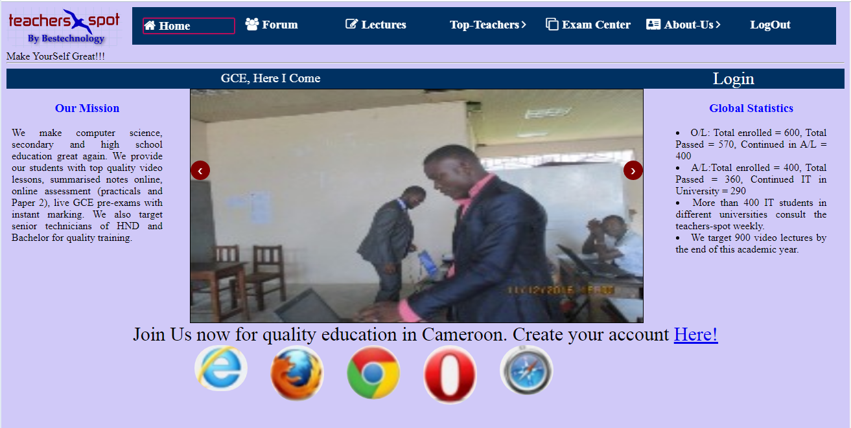Teachers-spot is a free e-learning platform put in place by BESTTECHNOLOGY & CO as a measure to fight against Covid-19 pandemic. The platform provides free video lessons from top teachers and examiners (also known as “LEGENDS”) within the Anglo-Saxon sub system of education. Real time revision with students and online evaluation are also powerful utilities of teachers-spot. Over three hundred and seventy-six (376) both students and teachers are actively present in this platform as from when this document is written. Teachers-spot can be accessed through the link <https://teachers-spot.com> Below is the Landing page of teachers-spot.com.

Figure 1.10: Landing page of teachers-spot.com

## 1.6. ORGANISATION

VTIB is a multi-level hierarchical institution with a simple organizational structure. It is headed by the Chief of Center (CoC). This position is occupied by Engineer Besong Michael E. Below the managing director are four departments. That is student affair, examination office, direction of training, and equipment control. Below is the description of each department and the services.

* **Student Affair (SA)**

The Student Affair is headed by Mme Victorine Kamga Prascede. This department is in charge of all the staffs and personnel in the institution. Student activities, learning, report card management, relation with parents and outside are all services of the student affair department.

* **Examination Office (EO)**

The examination office is in charge of organizing examinations, question quality, supervision of exams, overseeing correction of worked scripts and mark entry into the system. Handling queries including student marks and other complaints.

* **Direction of Training**

In charge of training, program quality, training duration, training time table and launching different certification programs. Drafting and designing training programs, ensure quality control, research and ameliorate training programs with international standards.

* **Equipment and Resource department**

This department is in charge of recommending and purchasing new training equipment, installing and configuring equipment, releasing equipment for practicals, maintaining equipment throughout life cycle.

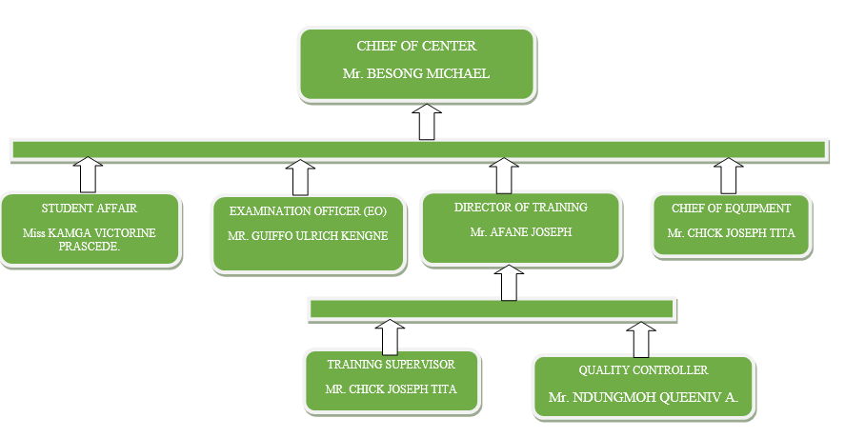

Figure 1.12: Organizational structure of VTIB